Input Boxes: JTextField and JTextArea

By: Oliver Barta

What Are Input Boxes in Java?
In Java's Swing GUI framework, input boxes are components that let users type in or view text inside a graphical interface. These are part of a category called input components, which also includes buttons, combo boxes, sliders, etc.

The two important input box types:
- JTextField – for single-line text input
- JTextArea – for multi-line text input/output

These are essential when building interactive Java programs that require user input or display information.

1. JTextField – The Single-Line Input Box

What It Does:
- Allows the user to enter text in a single line.
- Commonly used for forms, name entries, search bars, etc.

Syntax:
JTextField inputField = new JTextField();

You can also set its size like this:
inputField.setPreferredSize(new Dimension(250, 25));

Example code snippet:
JTextField nameField = new JTextField(20);
String name = nameField.getText(); // read input

Diagram:

2. JTextArea – The Multi-Line Text Box

What It Does
- Lets users input or display multiple lines of text.
- Great for chat windows, logs, comments, and displaying lists.

Syntax:
JTextArea textArea = new JTextArea(20, 30);

Adding Scrollbars (optional)
To allow scrolling, wrap it in a JScrollPane:
JScrollPane scrollPane = new JScrollPane(textArea);

Example Code Snippet:
JTextArea logArea = new JTextArea(10, 30);
logArea.setText("Name list:\nOliver\nJoe");
logArea.setEditable(false);

Diagram:
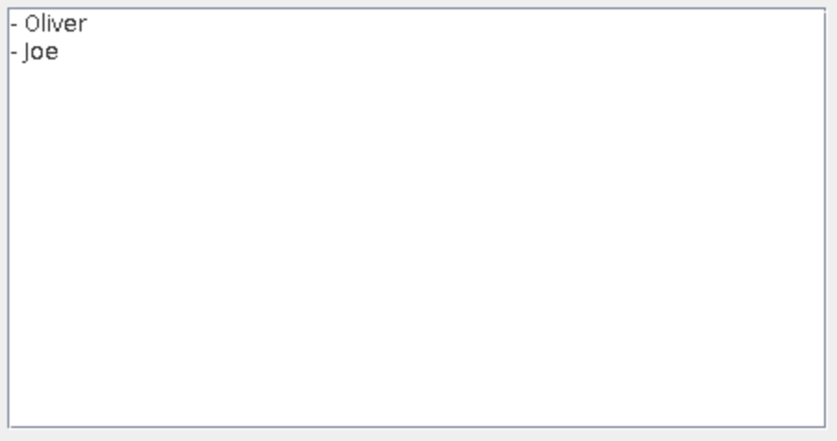

Useful Methods for both:
Method | What is does
getText() | Gets the text the user typed
setText(String text) | Sets the text inside the field

Summary table:
 | JTextField | JTextArea
Lines | Single line | Multiple lines
Purpose | Input short strings | input/display long text
Scrollable | No | Yes, with JScrollPane

Final Thoughts
- JTextField and JTextArea are essential for creating interactive applications.
- JTextField is ideal for short user input.
- JTextArea is best for displaying or entering large amounts of text.
- Combine them with buttons and labels to create a full GUI.

